

KANWAL SHEHZADI

02-131212-027



**QUESTION 01**

1. Model the transition system of traffic lights given in Figure # 01 in NuSMV

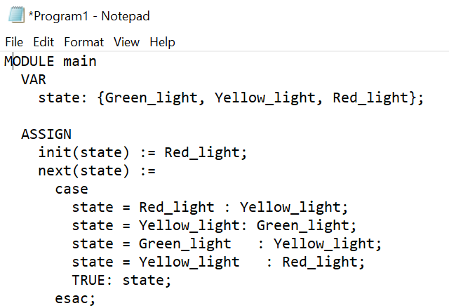

1. Print initial state and all reachable states of above transition system using NuSMV.

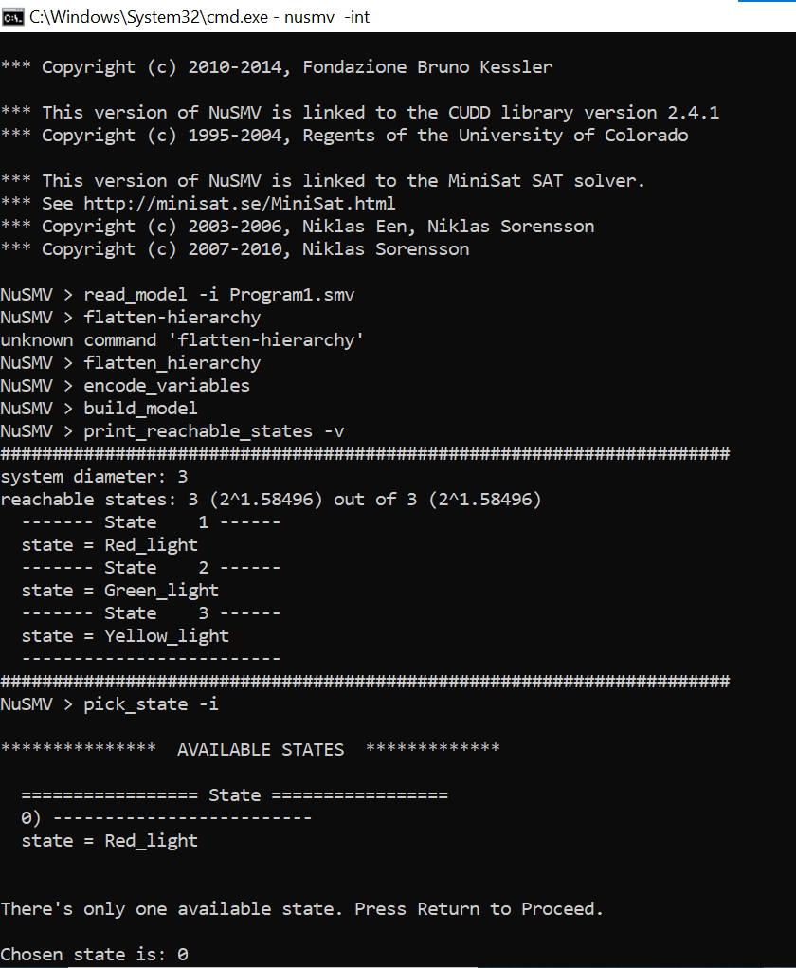

1. Write the safety property of traffic light system formally and informally.

* The informal description of the safety property is that the traffic light should never be in both the Green and Red states at the same time. This ensures that the system always adheres to the expected behavior of the traffic light.
* The safety property can be formally stated as a LTL (Linear Temporal Logic) formula

check_ltlspec G !(state = Green & state = Red); -- Safety property

**QUESTION 02**

1. Model the transition system given in Figure # 02 in NuSMV

1. Print initial state and all reachable states of above transition system using NuSMV

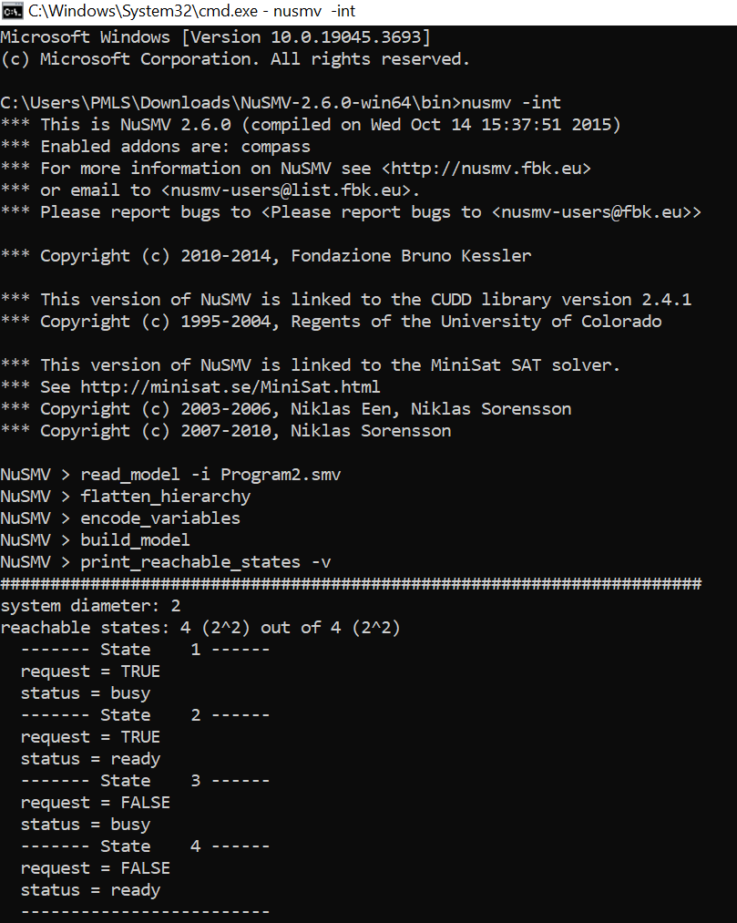

1. Simulate this model for 5 steps

(4) Identify whether the given LTL specification are true or false for the model (Figure. 2) using NuSMV

a. G(request -> F status=busy)

b. X(request = FALSE)

**QUESTION 03**

A) Write all possible (temporal) executions of this program (2 executions are mentioned here)

B) Construct a Büchi Automaton representing all executions of the above program.

